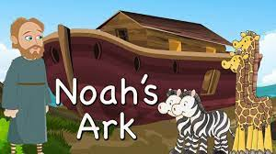
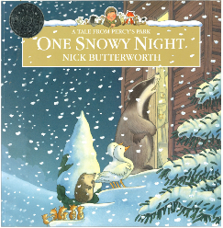
Willow Class Spring 1

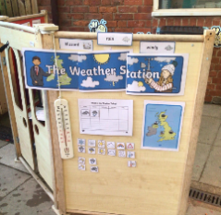
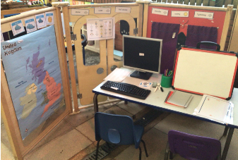
Wonderful weather has been a great topic to do this time, as we certainly have had all sorts of weather to look at! It has been a busy, but fun filled 6 weeks where the children have learnt all about the different types of weather.

In English we looked at the Percy the Park Keeper story, ‘One snowy night’ and the children wrote a fantastic piece of writing about a new character they thought of. We have also read the story of Noah’s Ark and the children wrote super sentences retelling the story.
In Maths, Year 1 have learnt about place value up to 50 and how to partition numbers into tens and ones. Reception have learnt everything to do with numbers up to 8 and had a go at combining two groups of numbers together. We had great fun on our Number Day and made some fantastic number hats and masks.
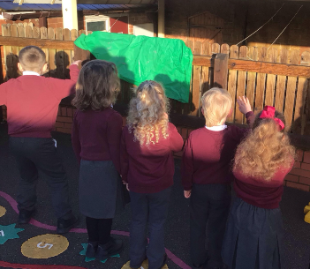
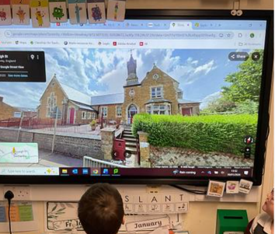
This term in science, Willow class have learnt about different types of weather and the symbols that represent them, they have also looked at seasons and discussed which is their favourite during our ‘Oracy week’. The children have also learnt about shadows and had great fun exploring with their own shadow. As part of Geography, we have taken a look at where we live and explored with google maps, ariel photos and made our own map with a key of our school.

We have had a great, but muddy time at Forest Schools this term. A firm favourite was the stick activities.


